Product Promotion Plan
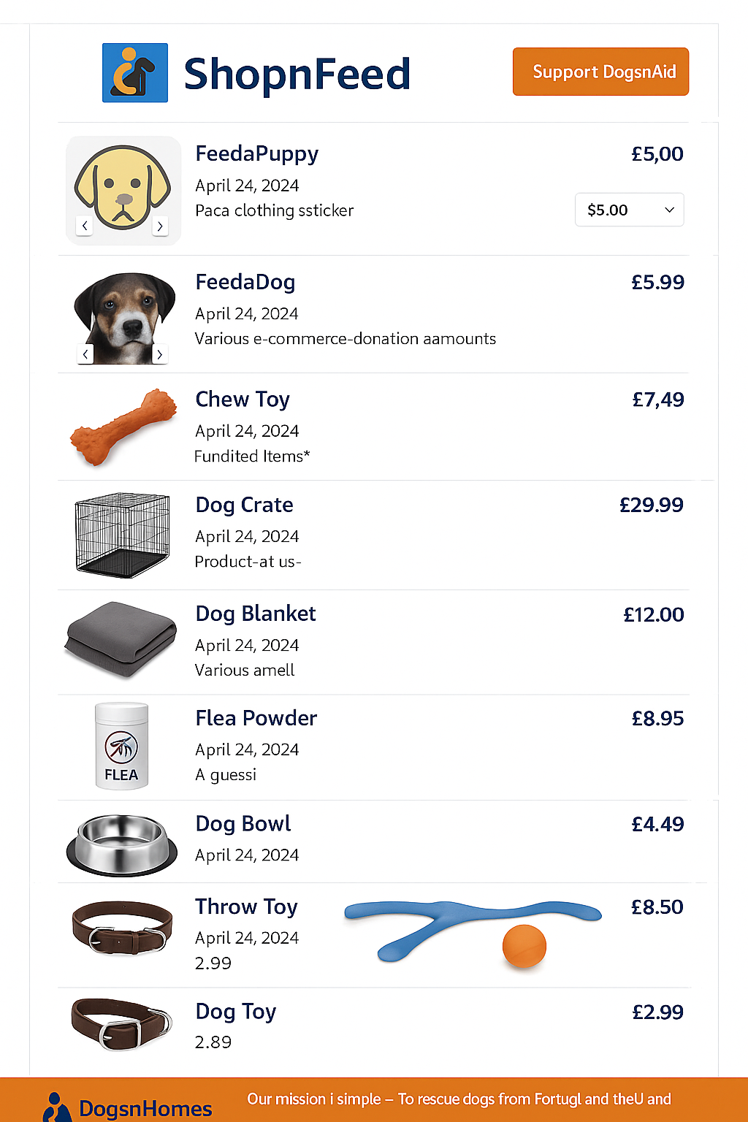
Page mockup shows “ShopnFeed” product promotion page, within https://dogsnhomes.org.uk required to sell products under DnH's charitable tax status. All product items are to be sorted by posting date-stamp, with at least one image per item, and some items will be flex-priced to encourage more generous payment options.
This page will use Spotify services for catalog entry and payment processing, but the physical order fulfillment will be forwarded to a third-party international shipping Partner, who: (a) picks from DnH-local storage, (b) prints labels, (c) brand-packages with thank-flyer, (d) prepays postage and export, and, (e) delivers item(s) to UK courier(s) or Royal Mail for non-returnable shipment.
Items include:
- Donation-items, only shipper-approved, as-new and dog-related
- Merchandise-items, brand-lines: “DogsnHomes”, “FeedaPup”, “DognAid Ukraine Convoy”
- “FeedaPup”-items, pinned-top-of-list, e.g. mini-patch, flex-price: £1, £10, £50 or £100.

Workflow

1. Gary creates and configures products in Shopify.
2. Shopify generates embeddable 'Buy Button' HTML for each product.
3. Rick creates a new WordPress page (e.g., '/shop' or '/support-ukraine').
4. Rick embeds the Shopify buttons using Custom HTML blocks.
5. The page is styled to match the DogsnHomes theme.
6. The page is tested for mobile responsiveness and user flow.
7. The page is published within DogsnHomes.org.uk, and linked to site navigation

Tasks

Product creation and pricing | Gary (via Shopify)
Payment processing and order tracking | Shopify platform
Embedding Buy Buttons into the site | Rick (via WordPress)
Page design and styling | Rick (matching DnH branding)
Fulfillment and shipping | Gary’s logistics Partner

Next Steps

- Generate Buy Button embed codes, via Gary's Shopify account
- Build and style the page within Shopify, (or WordPress).
- Integrate page into DogsnHomes website/navigation, not visible to public.
- Ask Michelle/team to review and test.
- Launch publicly, promote and upgrade if required.

